***Immunity Booklet***

**Pathogens**__

A pathogen is a microorganism that can cause disease. Examples include virus’ bacteria, fungi and parasites.

**Non Specific Defence**

Our body can defend itself against pathogens in a non specific way. This includes the following methods:

(i)**Hydrochloric Acid**: low pH kills the pathogen

(ii)**Epithelial Mucus:** Causes it to get stuck and cant attack any cells.

(ii) **The skin:** Physical barrier that it cant get through into the body

**If a pathogen manages to make it through these defence mechanisms, it is unlikely to escape the phagocyte*,* a type of white blood cell that can undergo the pathogen destroying process known as *Phagocytosis.* The following steps happen when a phagocyte comes into contact with a pathogen.

(i)The phagocyte is attracted to the pathogen by

Chemicals produced by the pathogen.

(ii)The phagocyte binds to the pathogen.

(iii)The pathogen is engulfed by the phagocyte and is

isolated in a phagosome

(iv) The phagosome within the phagocyte migrate

towards the lysosome.

(v) The lysosome release their enzymes into

the phagosome, where they digest the pathogen.

(vi)The breakdown products of the pathogen are released

By exocytosis or are displayed on the surface of the phagocyte

***Exam Question 1***

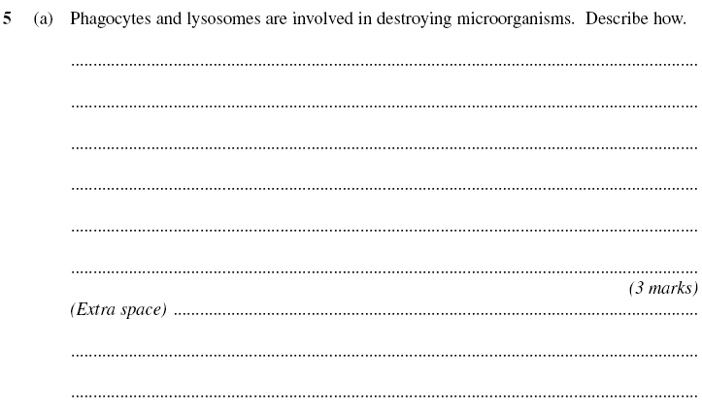

**Specific Defence**

Specific defence involves the *__________* eradication of pathogens. This can only happen if our body can _________________ between pathogens and our own body cells.

**Antigens**

Antigens are ________ (non self) proteins that are normally displayed on the _________ of a pathogen. Each type of pathogen has a _________ shaped antigen, but every pathogen of the same type has the _____ antigen. For example, vibrio cholorae (the bacteria responsible for ________) displays a different shaped antigen to mycobacterium tuberculosis (the bacteria responsible for TB). But every vibrio cholorae pathogen displays the same antigen, as does every mycobacterium tuberculosis pathogen.

This is slightly complicated by the fact that members of the same virus *do not* all always display the exact same antigen. The ________ virus is a classic example. Each influenza virus that displays a different antigen is called a ________. This explains why you can still can get the flu despite having had it a few weeks before.

Exam Question 2

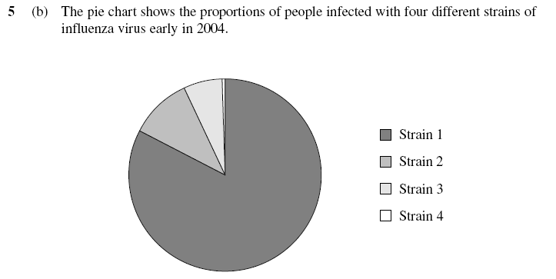

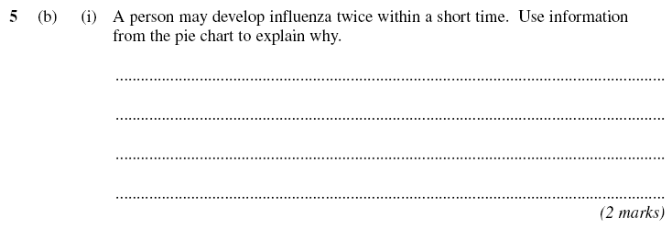

**Immunity**

When an antigen is recognised by a type of white blood cell known as a ___________, the resulting process is known as *____________,* the ability of our body to protect itself from a disease that we have already experienced. There are two interlinked types of immunity; *______ ___________ immunity* and *____________ immunity.*

**Cell Mediated Immunity**

*______________* are important in cell mediated immunity. Known simply as _______, they respond to ________ antigens that are attached to pathogens or the body’s own cells. The following diagram explains how a _______________ becomes activated:

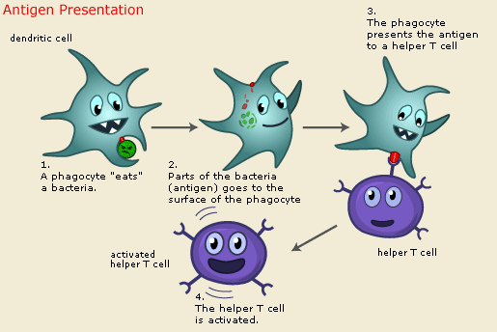

Receptor on the

T helper cell fits perfectly onto the antigen

When activated, the T helper cell divides rapidly by ____________, forming _______ of itself with identical ____________. The cloned T cells then:

1. develop into ________________ that enable a rapid response to future infections of the same pathogen
2. stimulate ________________ production (important in *humoural* immunity)
3. kill infected cells by making a protein that causes _________ of the cell’s surface membrane.

**Humoural Immunity**

Another type of white blood cell, the *______________* or *________* for short, is responsible for humoural immunity. When an ________ is encountered by a B cell, the following steps take place, leading to the production of *________________* and *________________:*

1. The surface __________ of the invading pathogen are taken up by ___________.
2. These antigens are then presented on the B cell’s ___________.
3. _______________ attach to these processed antigens, activating B cells to divide by mitosis into clones known as *__________________.*
4. These plasma cells produce ___________ that are *____________*  to the antigen.
5. These antibodies attach to antigens on the pathogen and destroy them. This is the *___________* response and as it takes time, the individual will suffer from symptoms of the disease.
6. Some B cells develop into ______________. These cells divide rapidly and turn into __________ producing ____________ when our body is infected later by the same pathogen. This is the *___________* response and the pathogen is destroyed before it can cause any _________________.

**Antibodies**

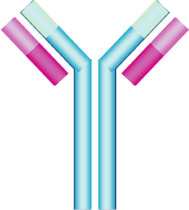

Antibodies are released by B cells in response to a specific

antigen. They are a protein made of _______ chains. The two

longest chains are called *________ chains.* The two short

chains are called *_______ chains.* The *_____________________* is

at the __________ of the Y shape and is also known as the *_________*

*___________* because it is different on different antibodies. The

rest of the Y shape is called the _____________ region because

it is exactly the same for every antibody.

________________________ are antibodies that are produced from a single __________ of B cells. They can be made in the laboratory using the following method:

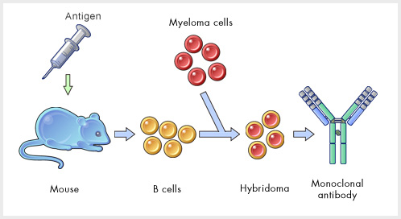

**Vaccination**

________________ is produced by introducing ____________ from an outside source (e.g. ______________ antibodies). This immunity is short lived. _______________ is produced by stimulating the body to produce its own antibodies (e.g. ____________). This is long-lasting.

Vaccination involves the introduction into the body of a vaccine containing a dead or ______________ pathogen or a toxin. The __________ are recognised by the body and an immune response occurs. _______________ are made during this process which remain _____________ in the body, ready to divide rapidly when they come into contact with the same ____________.

If you vaccinate every member of the population against a disease you should be able to eradicate it. Here are a few reasons why vaccination _____________ eliminate a disease:

1. The pathogen may _____________ frequently so that its antigens change. This is called ________________________. The ___________ virus and _________ bacterium is capable of doing this. The body will not have ________________ for the new antigens and so is not _____________.
2. There is often many different varieties or ___________ of a particular pathogen each with their own unique shape of __________. There is around ________ strains of the ___________________ virus for example.
3. Certain pathogens _________ from the immune system e.g. ____________ or within the _______________.
4. Some people object to vaccination for ____________ or ____________ reasons.

Exam Question 3

